In python, Pickling is taking a list of data into a serialized format. This is useful for data that is in a wrong format.

Point 1)

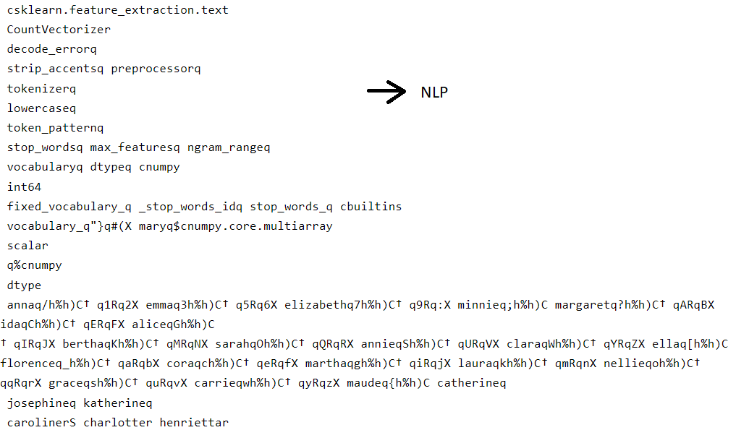Then the rest of the names are lists of objects that have been inputted.

Point 2)

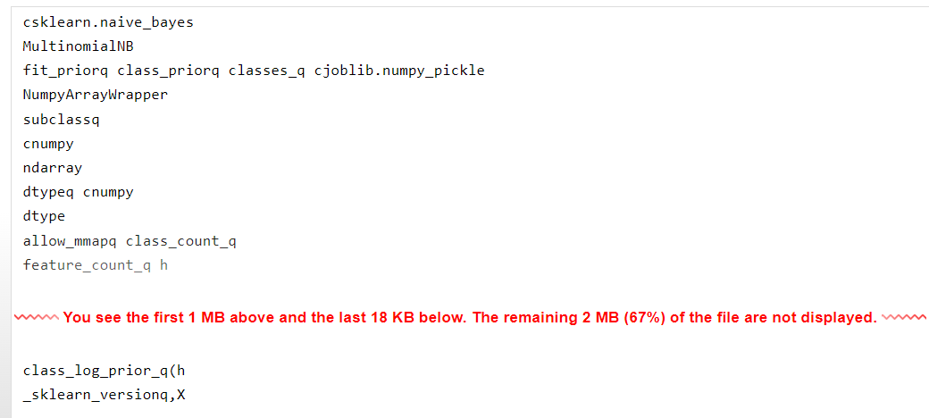

* Naïve bayes is a method to predict the probability of different class based on various attributes.
* The multinomial Naive Bayes classifier is suitable for classification with discrete features
* The rest of the codes are for machine learning, like feature count to find occurrence distribution, and to re-structure an array like ndarray, numpyarraywrapper.
* The model itself is not shown and can’t be shown.

IMPLEMENTATION

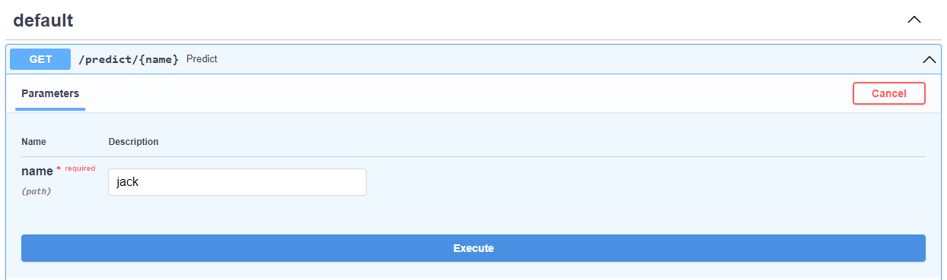press execute

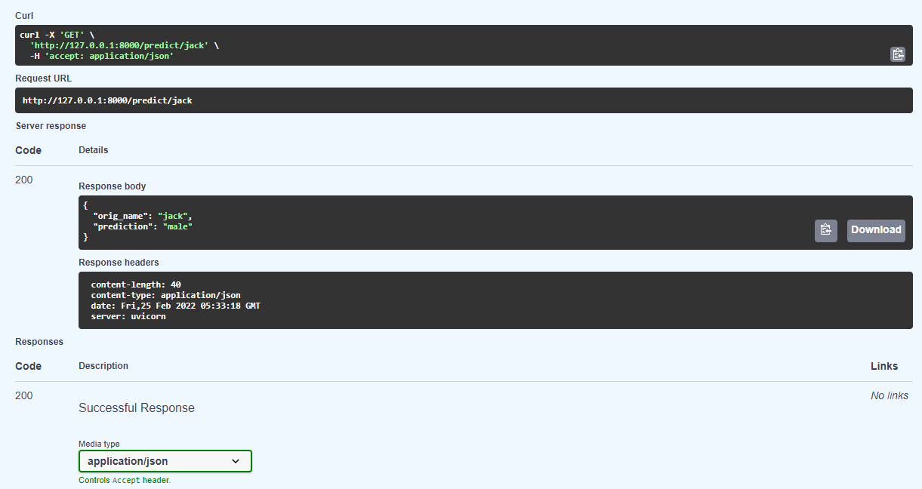When we input jack, the prediction is correct which is a male.

Integrating KAFKA with our API

Run zoo and the server of KAFKA

Zookeeper



Kafka server



After, run the app.py

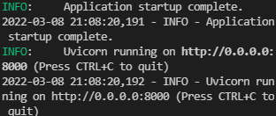

Run the producer.py that sends the value which is the name

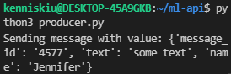

Then on the app will return the prediction



The consumer will receive the message

The result is

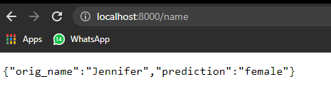

Another test

